## Use and instructions of myStudio software

1. Open myStudio and enter the home page (robot selection page)

Double-click the system icon (as shown in Figure 3.1) to run the program and enter the home page of the system, as shown in Figure 3.2.

1. Select robot: Select a different robot series by clicking on the picture, such as myCobot280 series. Click the model option below to select a specific model of this series of robots, as shown in Figure 3.2. The currently selected model is myCobot280 for m5.
2. USB port connection: Click the USB port connection option and select the USB port to connect to the robot. The default is empty. When the user connects the robot using USB, the port will be automatically identified for the user to select and connect, as shown in Figure 3.3, M5 Stack-basic connected to the robot's port.
3. Language: Click the language option and select the system language. Currently supports Chinese, Japanese and English.
4. Region: Click the region option and select a region. The options are: Mainland China and other regions.
5. Login: Complete the login by clicking the Login button.



Figure 3.1 System icon

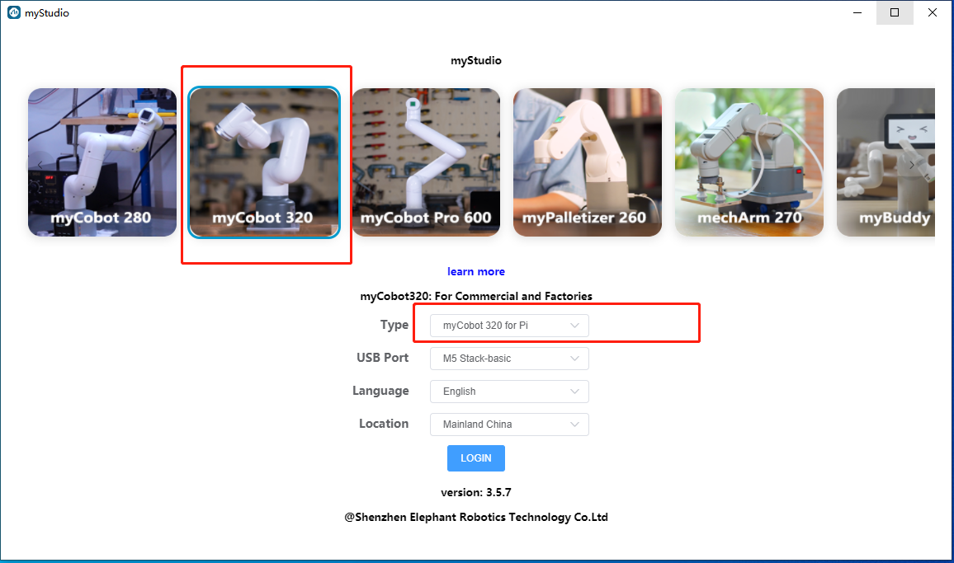

Figure 3.2 System home page

Figure 3.3 M5 Stack-basic port

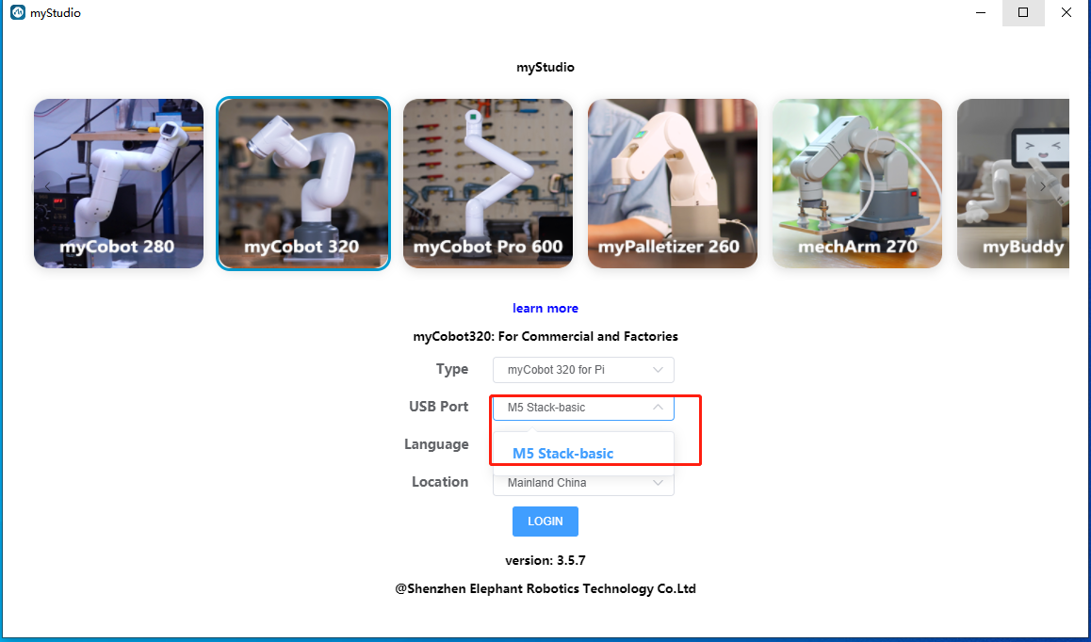

1. After logging in, you will enter the main page of the system, as shown in Figure 3.4.

The main page is mainly divided into three parts, as shown in Figure 3.5:

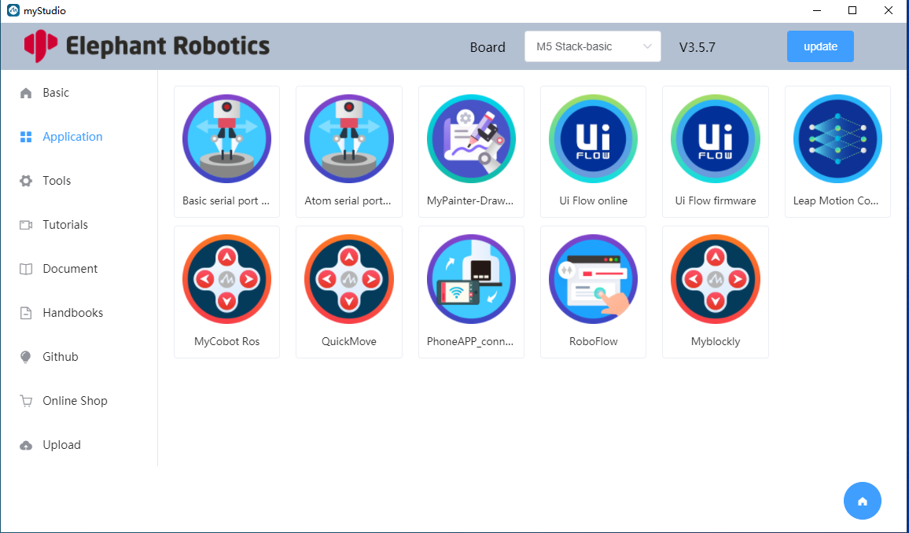

Figure 3.4 Main page

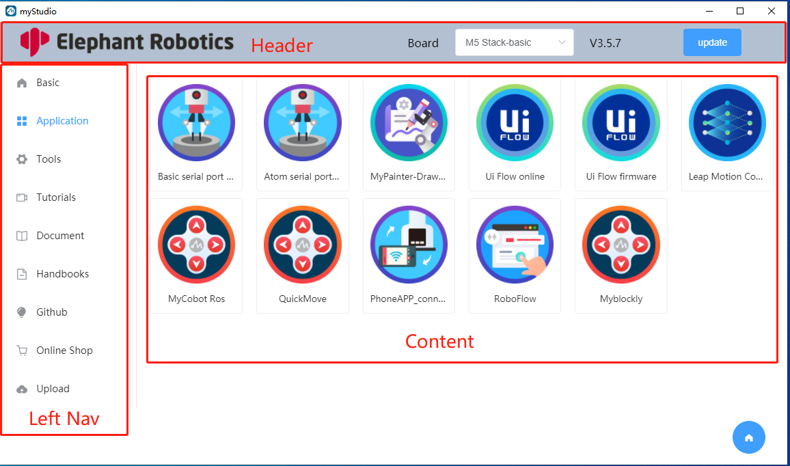

Figure 3.5 Main page structure

1. Header: As shown in Figure 3.6 , the company logo is displayed; the currently connected USB port is displayed, and the user can choose to change it, as shown in Figure 3.7; the version number of this system, the latest version is v3.5.2;

System update operation, click the update button to trigger the detection of updates, as shown in Figure 3.8. Wait for the detection update to end, as shown in Figure 3.9.

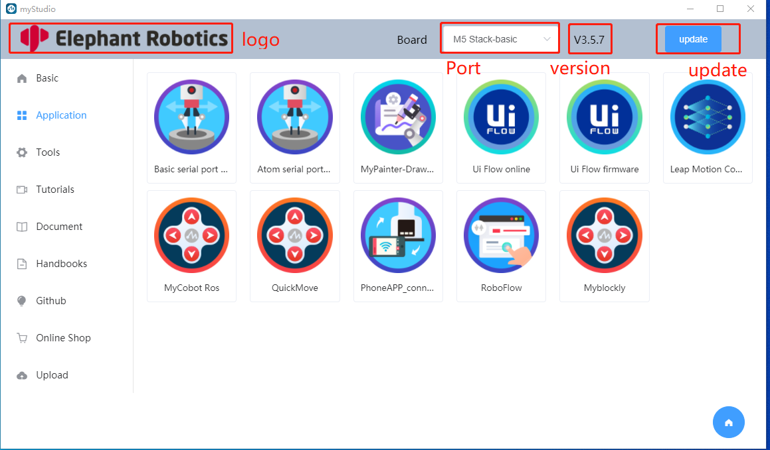

Figure 3.6 Head

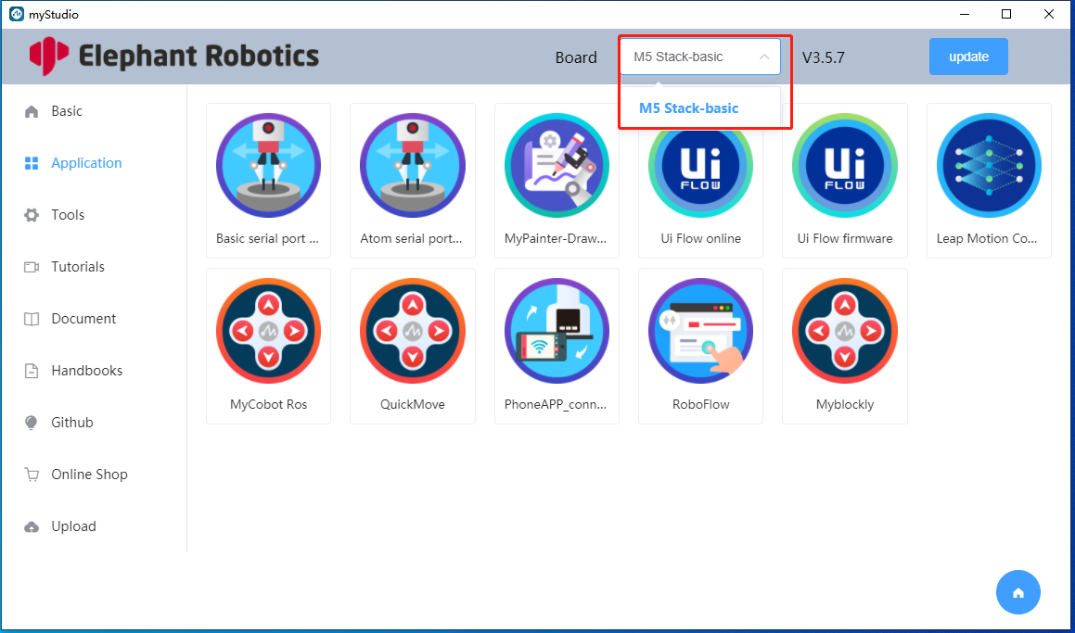

Figure 3.7 Switch port

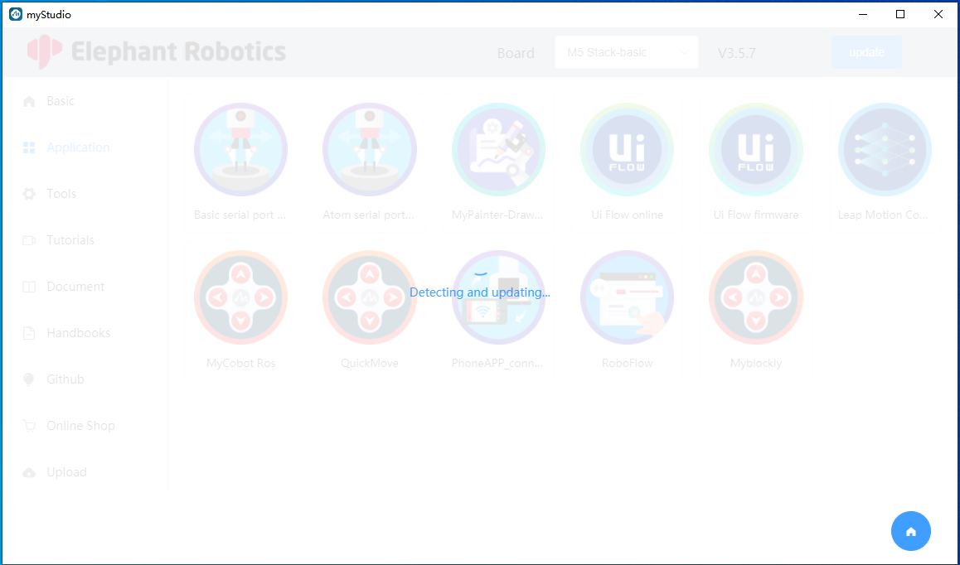

Figure 3.8 Detecting updates

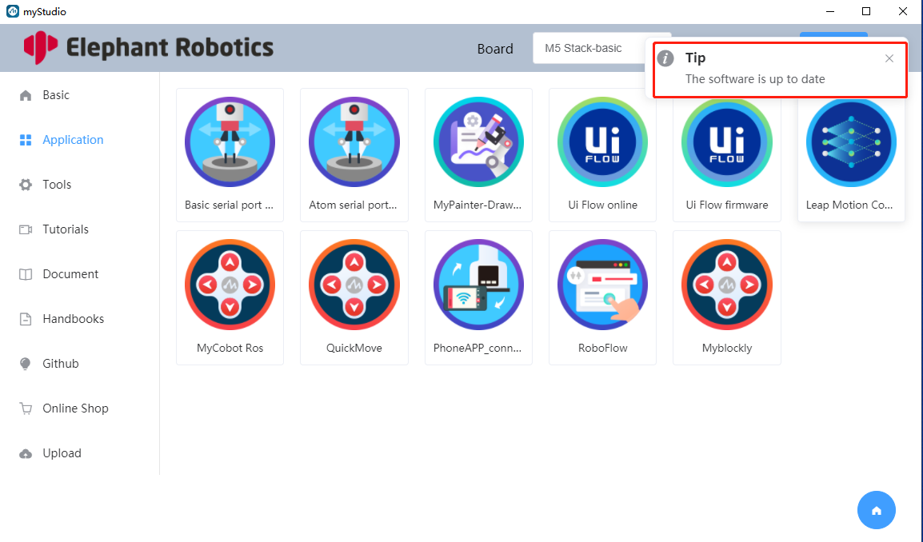

Figure 3.9 Detection update completed

1. Left navigation bar: As shown in Figure 3.10, users can switch pages by clicking on the options on the left navigation bar. Each option represents a page, and the options in blue font are the current page. As shown in Figure 3.10, it is currently the application page.

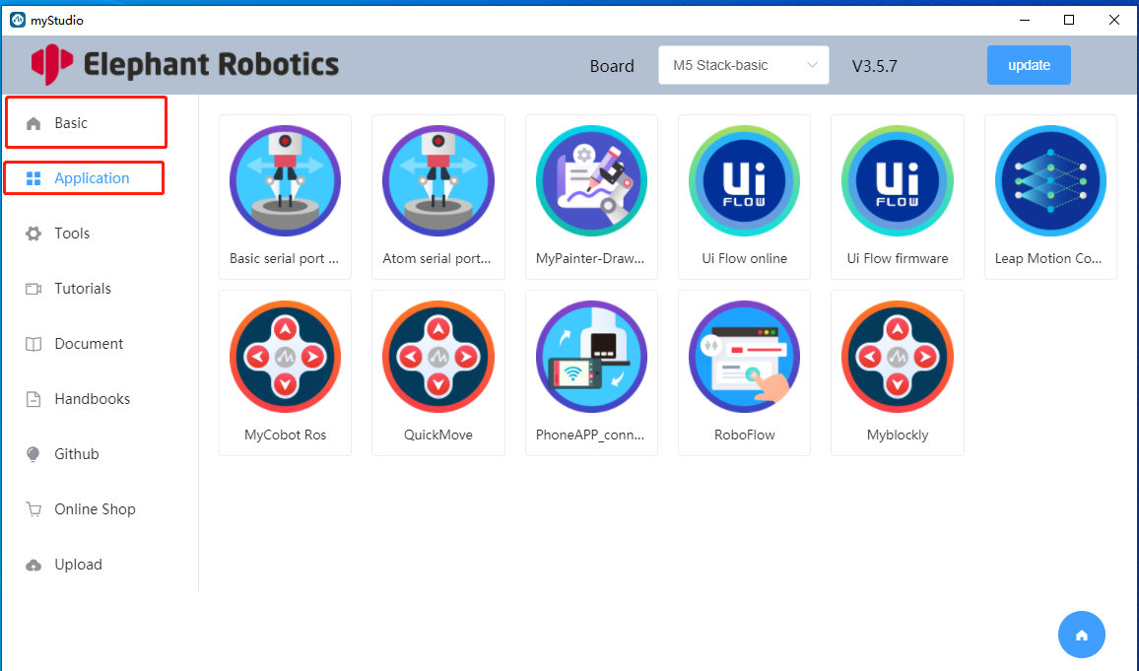

Figure 3.10 Select application page

1. Page content area: displays the main content of the page. As shown in Figure 3.11 , if the application option is currently selected in the left navigation bar, the content of the application page will be displayed.

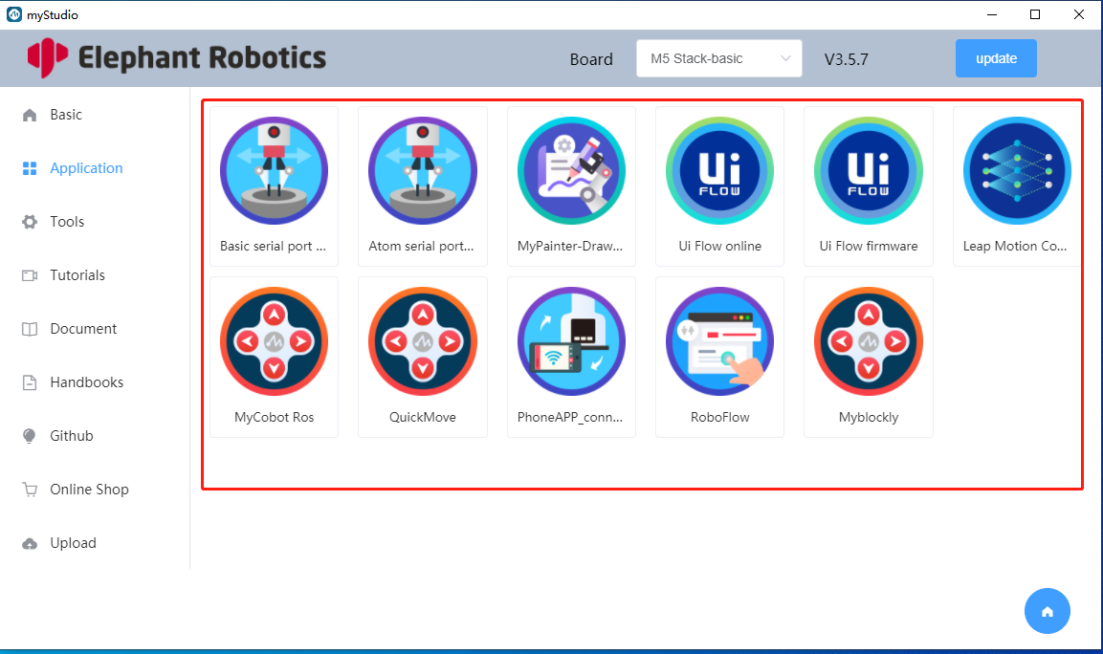

Figure 3.11 The page content area displays the application page content

1. Application page: You can download serial port driver, UiFlow firmware, etc.

Click the application option on the left navigation bar to enter the application page. After clicking the Basic serial port driver card (as shown in Figure 3.12), it will jump to the browser page to download the Basic serial port driver (as shown in Figure 3.13). This serial port driver is used to identify the robot serial port. After decompressing the serial port driver compressed package, go to the CP210x_VCP_Windows directory and select the .exe suitable for your operating system version to install, as shown in Figure 3.14.

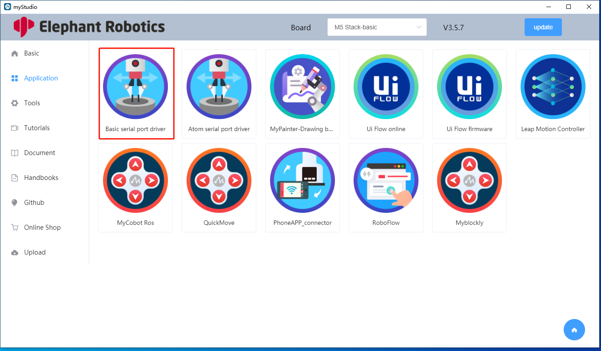

Figure 3.12 Basic serial port driver card

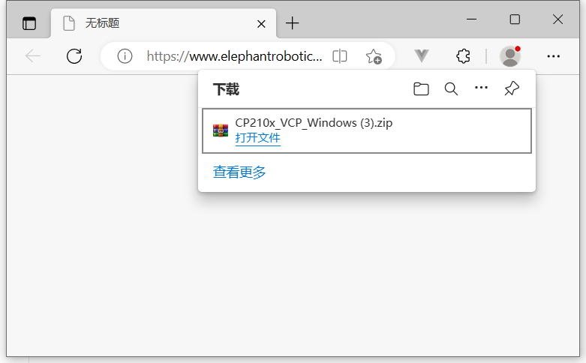

Figure 3.13 Browser download driver

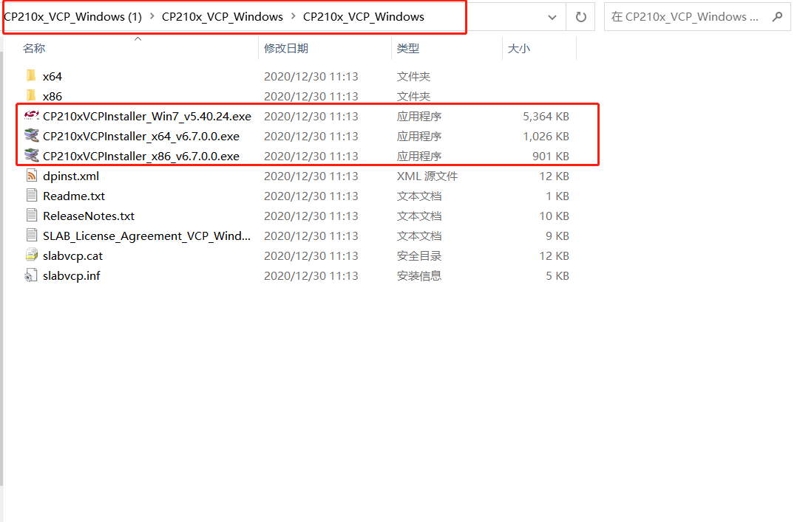

Figure 3.14 CP210x_VCP driver

After clicking on the Atom serial port driver card (as shown in Figure 3.15), it will jump to the browser page to download the Atom serial port driver. This serial port driver is used to identify the robot Atom serial port, as shown in Figure 3.16. After decompressing the serial port driver compressed package, you can double-click CDM21228_Setup.exe to install the driver, as shown in Figure 3.17.

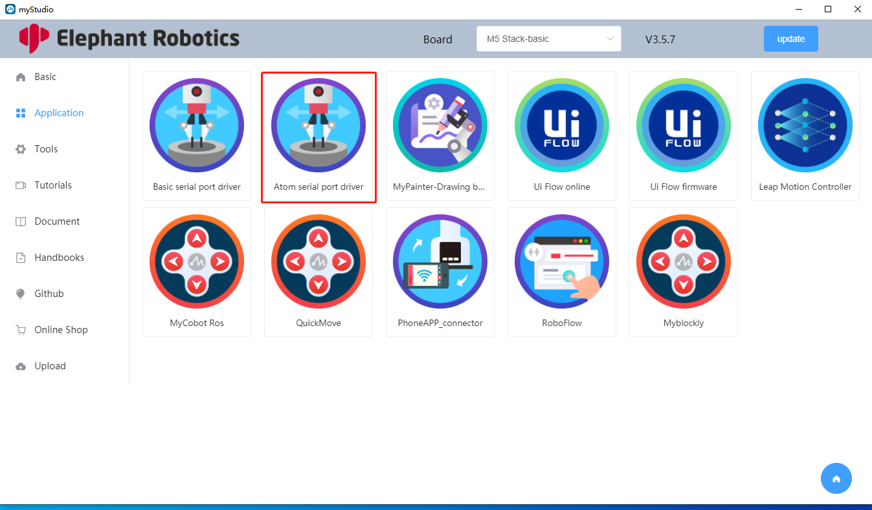

Figure 3.15 Atom driver card

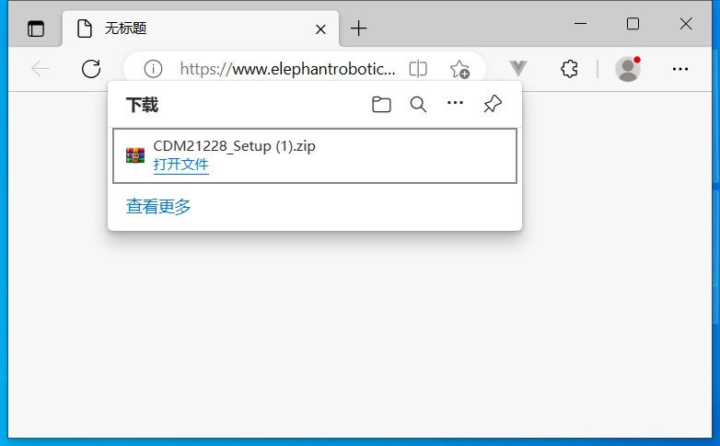

Figure 3.16 Browser downloads Atom serial port driver



Figure 3.17 Atom serial port driver installation package

1. Basic page: Download and burn firmware

Click the Basic option in the left navigation bar to enter the Basic page, as shown in Figure 3.18.

Enter the Basic page. Each card in the main content area is a piece of firmware information (as shown in Figure 3.18), which includes the name of the firmware, description information of the firmware, and version.

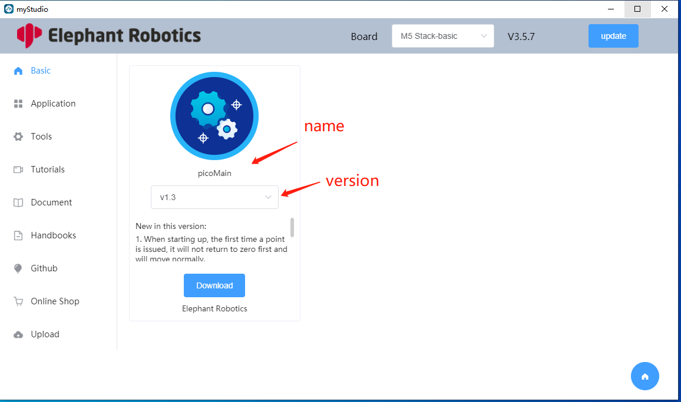

Figure 3.18 Basic page

Users can choose different firmware versions to download, as shown in Figure 3.19.

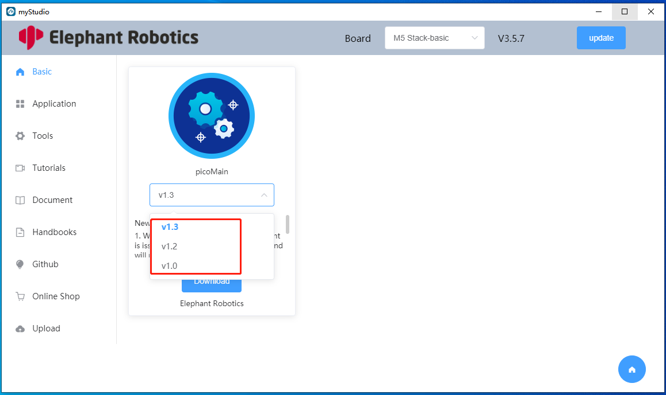

Figure 3.19 Select firmware version

Click the download button, and a download confirmation box will pop up, displaying the current firmware information. Click the OK button to start the download (as shown in Figure 3.20). After clicking the OK button, the real-time download progress is displayed on the interface (as shown in Figure 3.21). After the download is completed, the firmware can be burned.

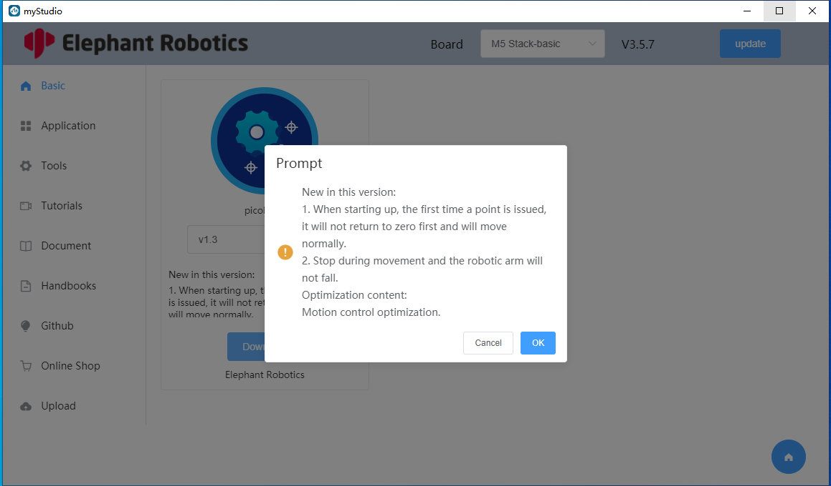

Figure 3.20 Download pop-up box

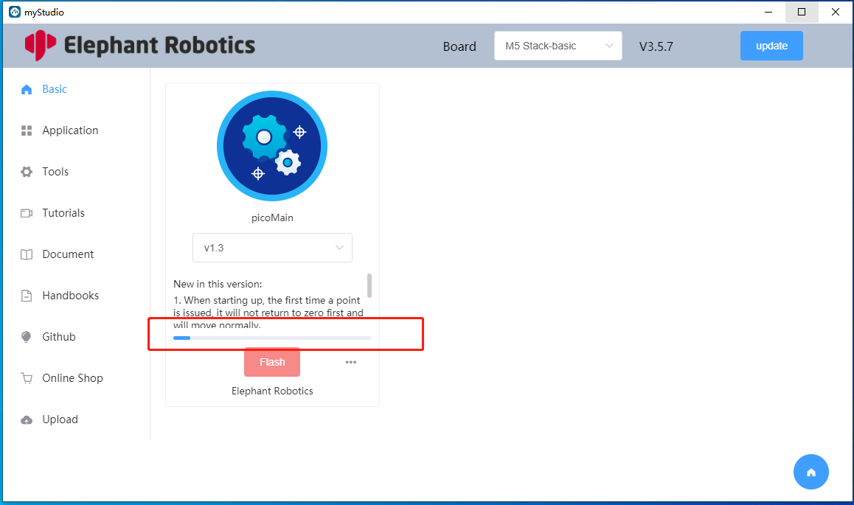

Figure 3.21 Download progress bar

After clicking the burn button below the miniRobot firmware, a burning progress information box will pop up, displaying the burning progress and information in real time (as shown in Figure 3.22 ). After the burning is completed, it will prompt that the burning is completed and the burning progress information box will be automatically closed.

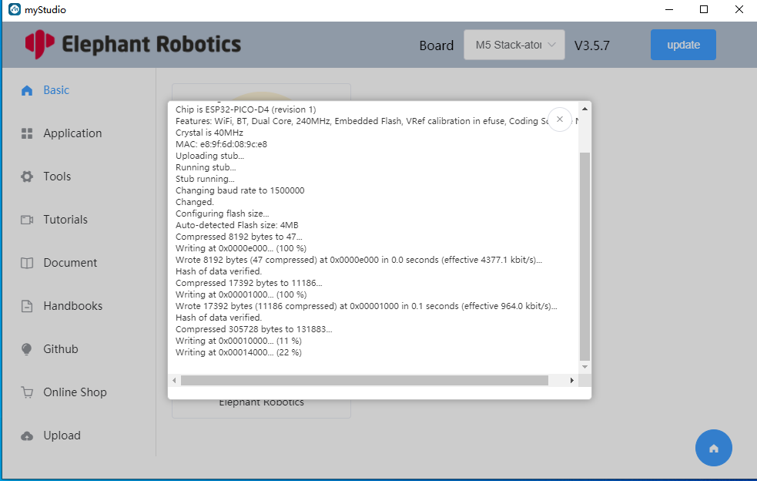

Figure 3.22 Firmware burning information box

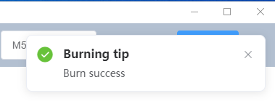

Figure 3.23 Firmware burning completion prompt

After the firmware burning is completed, you can choose to delete the firmware. Click the three small dots next to the burn button, and a delete button will pop up, as shown in Figure 3.24 . Click the delete button, and the deletion confirmation prompt box will pop up (as shown in Figure 3.25 ). Click Confirm to delete the downloaded firmware (as shown in Figure 3.26 ). After the firmware is deleted, the burn button will become a download button.

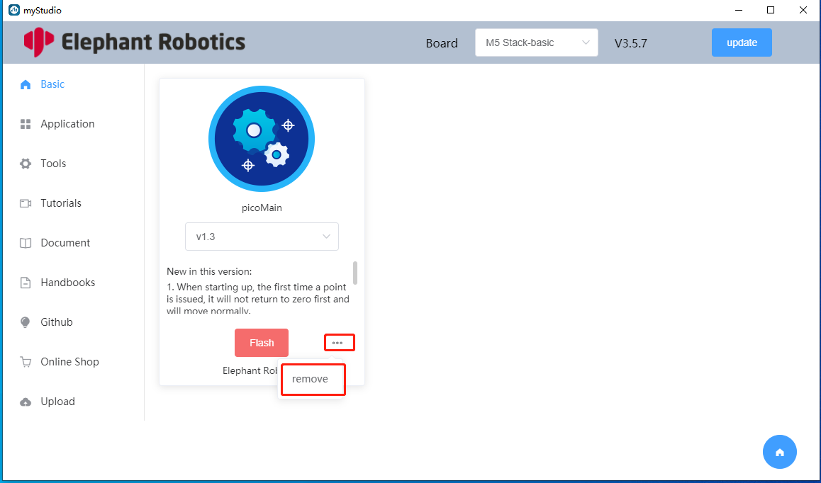

Figure 3.24 Delete button

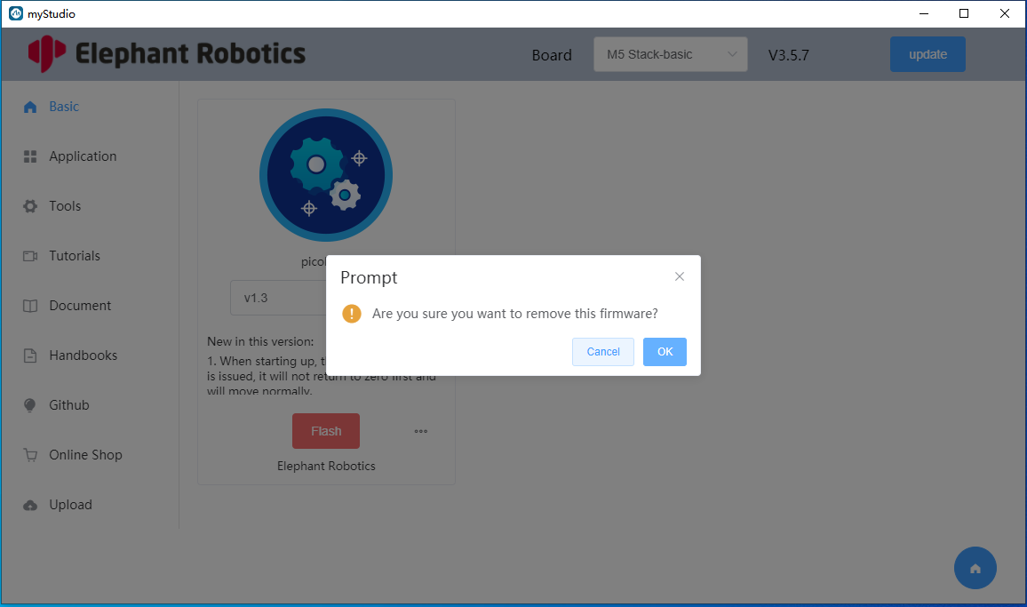

Figure 3.25 Delete prompt box

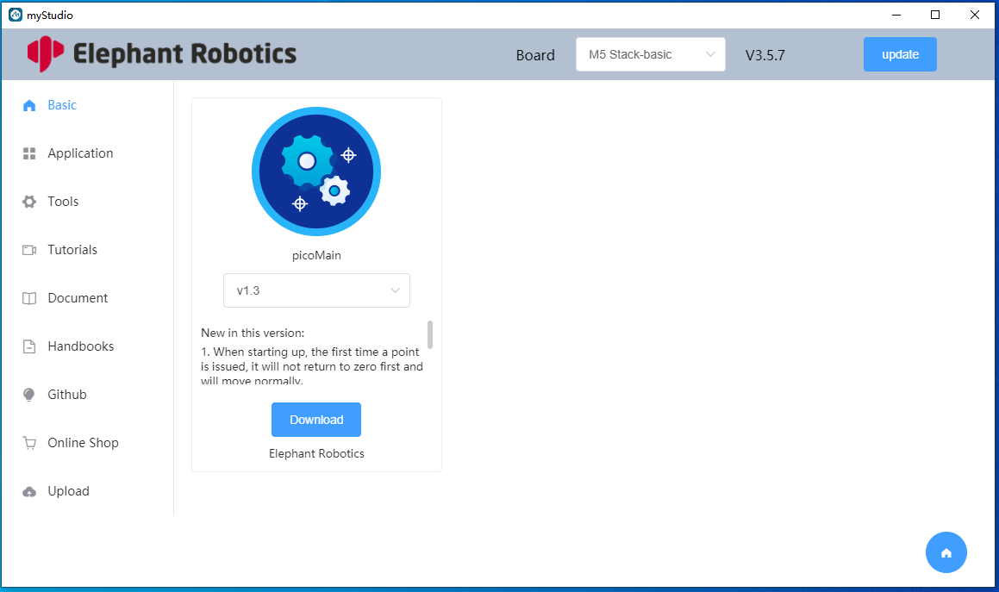

Figure 3.26 Firmware deletion completed

1. Tutorial page:

The user clicks the tutorial option on the left navigation bar to enter the tutorial page, as shown in Figure 3.36 .

Click on the video, and a webpage will pop up to start playing the video, as shown in Figure 3.37 .

Click the close button in the upper right corner of the pop-up page to close the page.

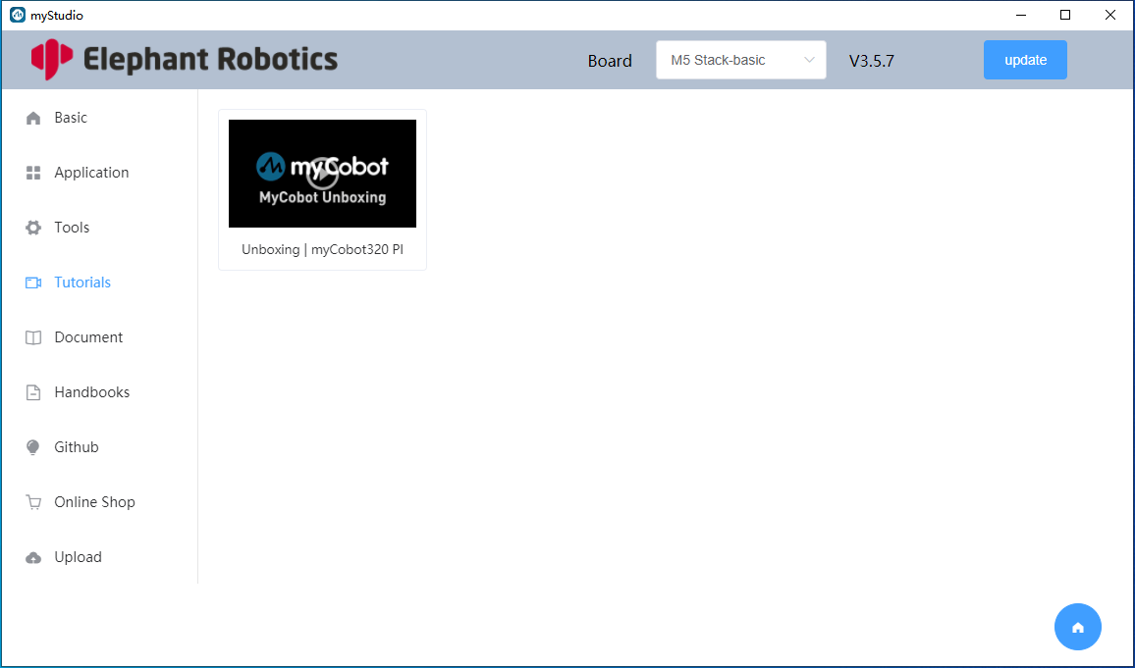

Figure 3.36 Tutorial page

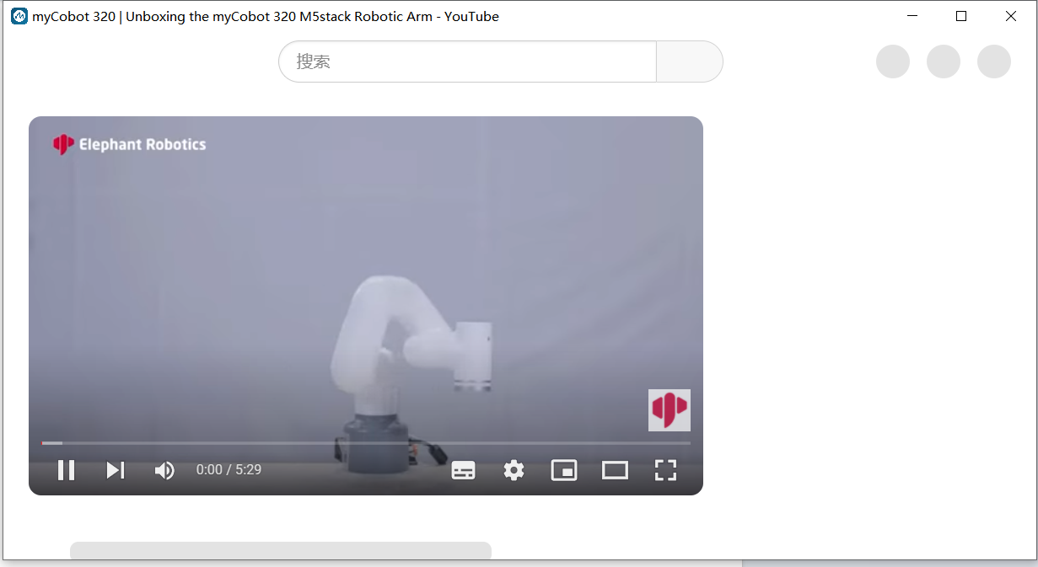

Figure 3.37 Video tutorial web page

1. Documentation page

Users can click the Document option on the left navigation bar to enter the documentation page to view the instructions for use of the current model of robot. Among them, the left side of the document is the directory bar (as shown in Figure 3.38 ), and you can choose to click to view different tutorials.

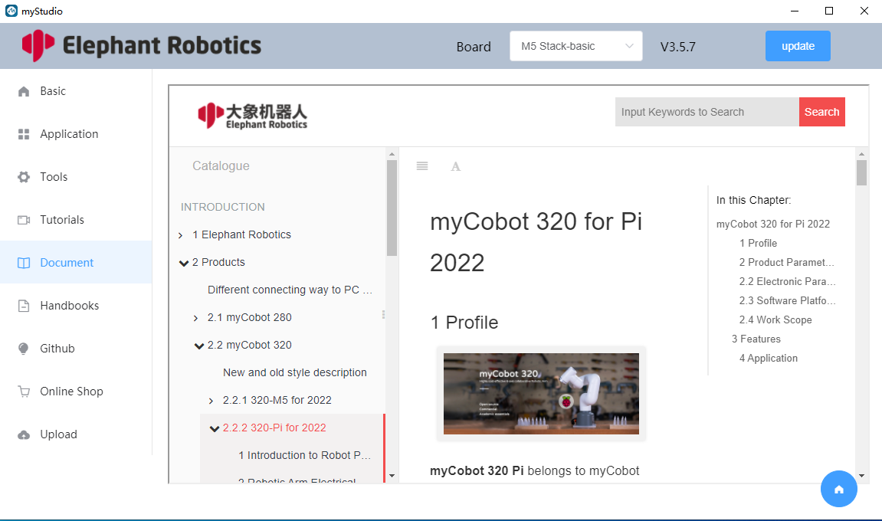

Figure 3.38 Documentation page

1. man page

The user clicks the manual option on the left navigation bar to enter the manual page, as shown in Figure 3.39 . On this page, users can choose to view the user manual, product brochure, and developer guide manual.

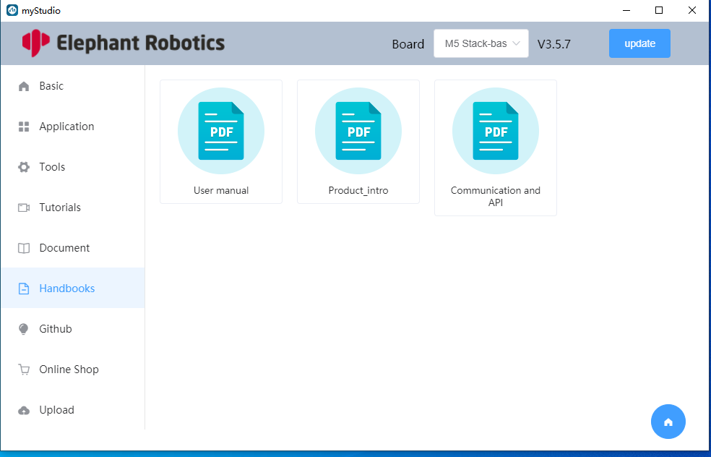

Figure 3.39 Man page

1. Github page

The user clicks the Github option on the left navigation bar to enter the Github page of this system, as shown in Figure 3.40 . On this page, users can click on the option to jump to the company's Github warehouse page.

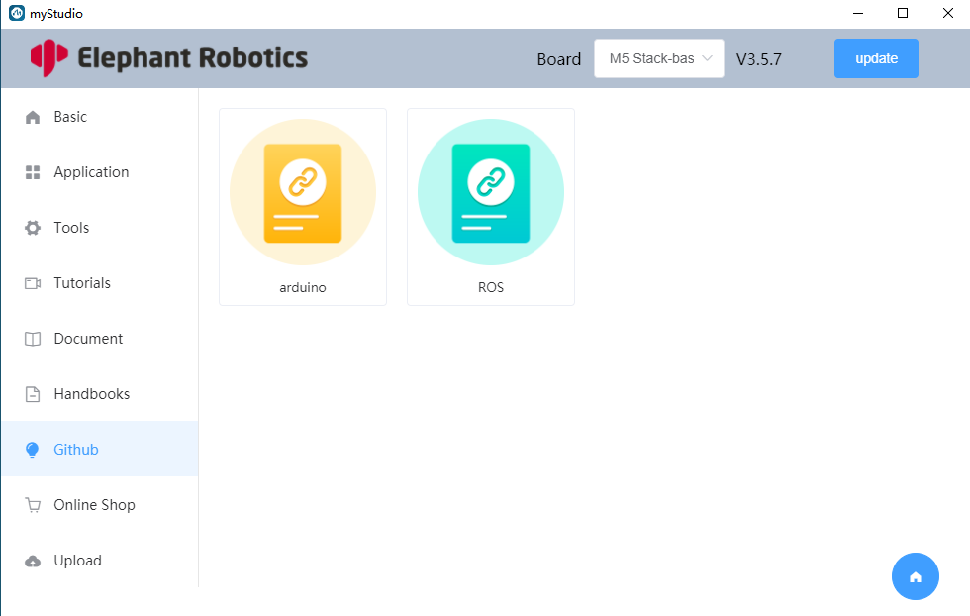

Figure 3.40 Man page

1. Mall page

The user clicks the mall option on the left navigation bar to enter the mall page, as shown in Figure 3.41 .

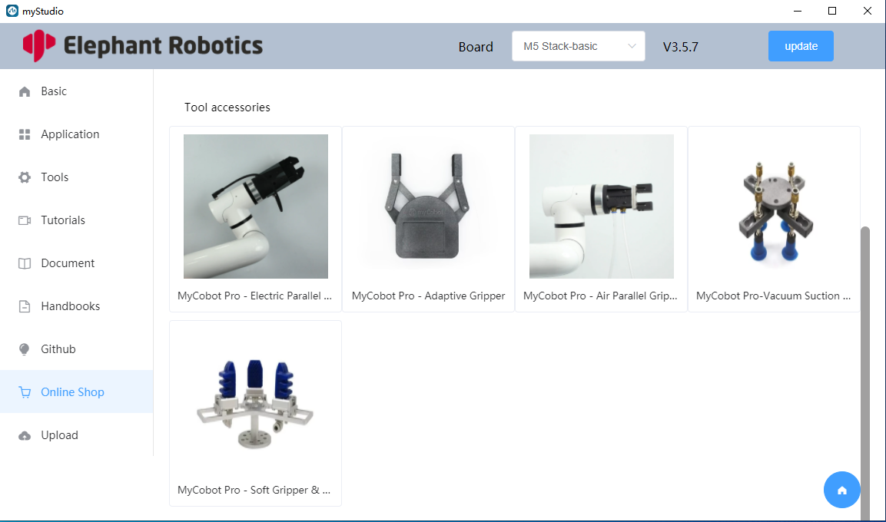

Figure 3.41 Mall page

1. Contact us page

The user clicks the Contact Us option on the left navigation bar to enter the Contact Us page, as shown in Figure 3.42 .

On this page, users can fill in the form content and click the submit button to send an email to our company's mailbox.

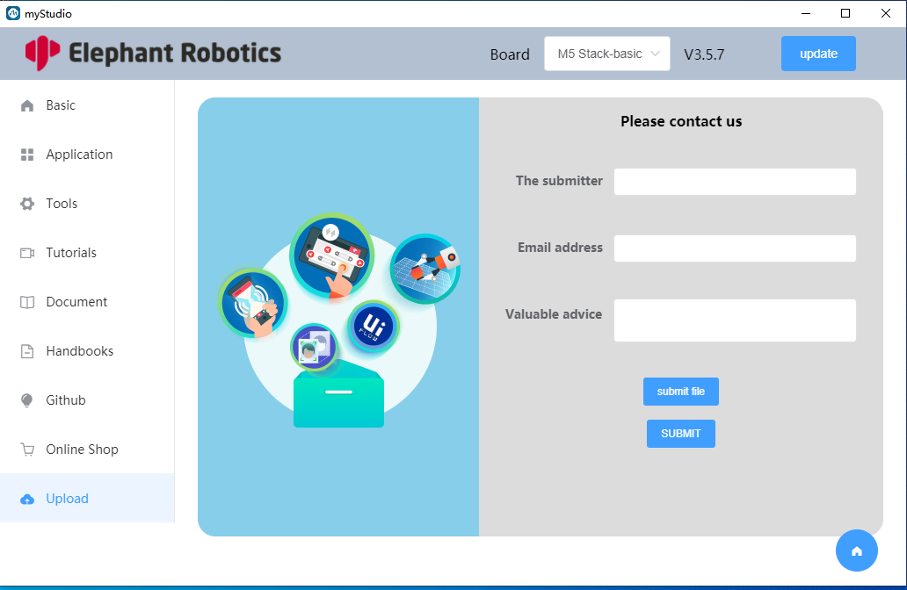

Figure 3.42 Contact page

1. Return to login page

The user can return to the homepage by clicking the return button in the lower right corner of the main content area. The return button is shown in Figure 3.43.

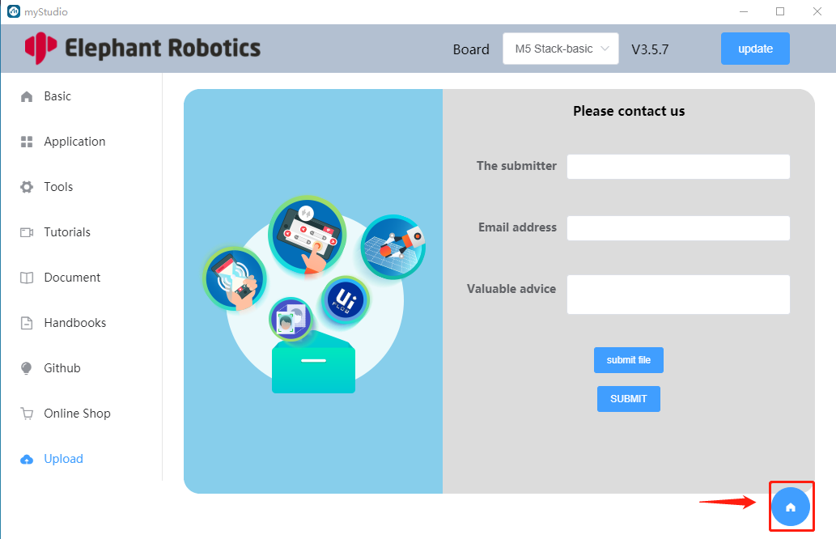

Figure 3.43 Return button

1. exit the program

Click the close button in the upper right corner of the software to exit the software, as shown in Figure 3.44

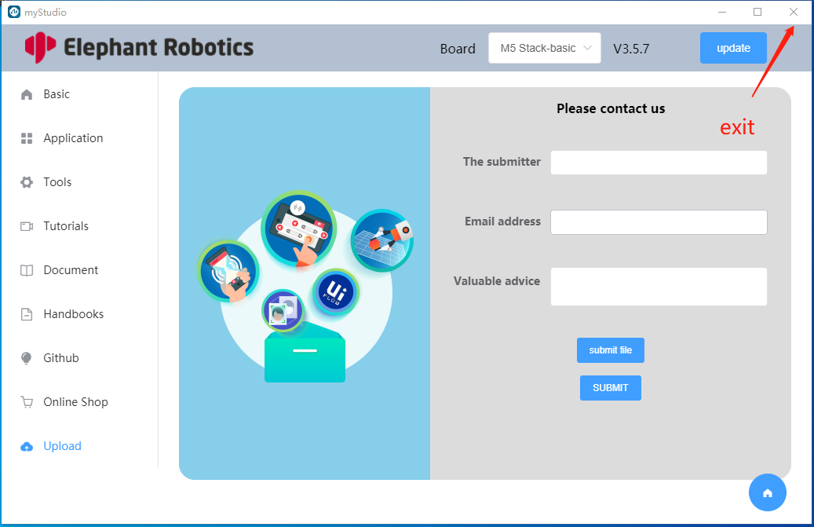

Figure 3.44 Exit button